**POTENTIAL FISHING AREA RECOGNITION AND GUIDANCE SYSTEM**

Amrith Venkat K, III Year EIE, Sri Ramakrishna Engineering College

Mukesh Kumar, III Year EIE, Sri Ramakrishna Engineering College

Jeevaraam K, II Year EIE, Sri Ramakrishna Engineering College

Rakul Kannan K, II Year EIE, Sri Ramakrishna Engineering College

***Under Guidance of***

Dr.K.Srinivasan, Head of Department, Department of Electronics and Instrumentation Engineering,

Sri Ramakrishna Engineering College

**OBJECTIVE**

In Today’s Scenario, the location of potential availability of fish remains as a system without hands. The location is present as data in the website or server and on the Coasts as a display on LCD Screen. This project aims to acquire this data for the use of even small-scale fishermen and guide them to reach the potential fishing spots near their location. This system makes it possible for the fishermen to reach these potential spots with ease. This system will be in continuous contact with the fishermen and will be with them all the time.

**TECHNICAL DETAILS**

This Project consists of two Systems, the Shore System and the Mobile System. The Shore System is basically a self-service system. It is kept connected to the internet and used to acquire and update the potential fishing areas. These potential fishing areas are mapped by Remote Sensing Technologies and made available to the Public by the Government itself under the name of INCOIS (Indian National Centre for Ocean Information Service). The Potential Fishing Zones are divided into 14 coastal regions throughout the country. This data is hosted in a Public domain by Government. This data is downloaded by the Shore System and the data is converted to a specific format readable by the Mobile System. This data is then transferred to the SD Card of the user.

The Mobile System consists of GPS Receiver, Central Controller, LCD Display and SD Card Reader. The Central Controller consists of Arduino unit and Four Input buttons. The Mobile System first checks for the stored Location Data in the SD Card. If data is found, the location will be displayed to the user from which the user can select his preferred destination region. Then, the system starts to receive the present location data from the attached GPS Module. The Controller compares the present location with the user defined location and indicates its absolute bearing and distance to location. If the location is reached, a signal indicating the same is displayed. Caution is taken to see that international water boundaries are not crossed by referencing the co-ordinates present on the SD card and the Internationally agreed boundaries.

The Potential Fishing Zone data is refreshed by the INCOIS frequently. While the user registers himself for the first time in the Shore System, his contact number is also received and stored. Whenever the INCOIS data is refreshed and the Shore System completes updating the same, an intimation will be sent to the registered contact numbers so that the Potential Fishing Zones are not out-dated. The International Border Co-ordinates are stored in such a way that these data cannot be tampered with. In addition to these precautions, the Shore System feeds a special message to the SD Card regarding the region of the fishermen so that the fishermen of one region do not go to other regions and exploit the opportunities of native fishermen of that region.

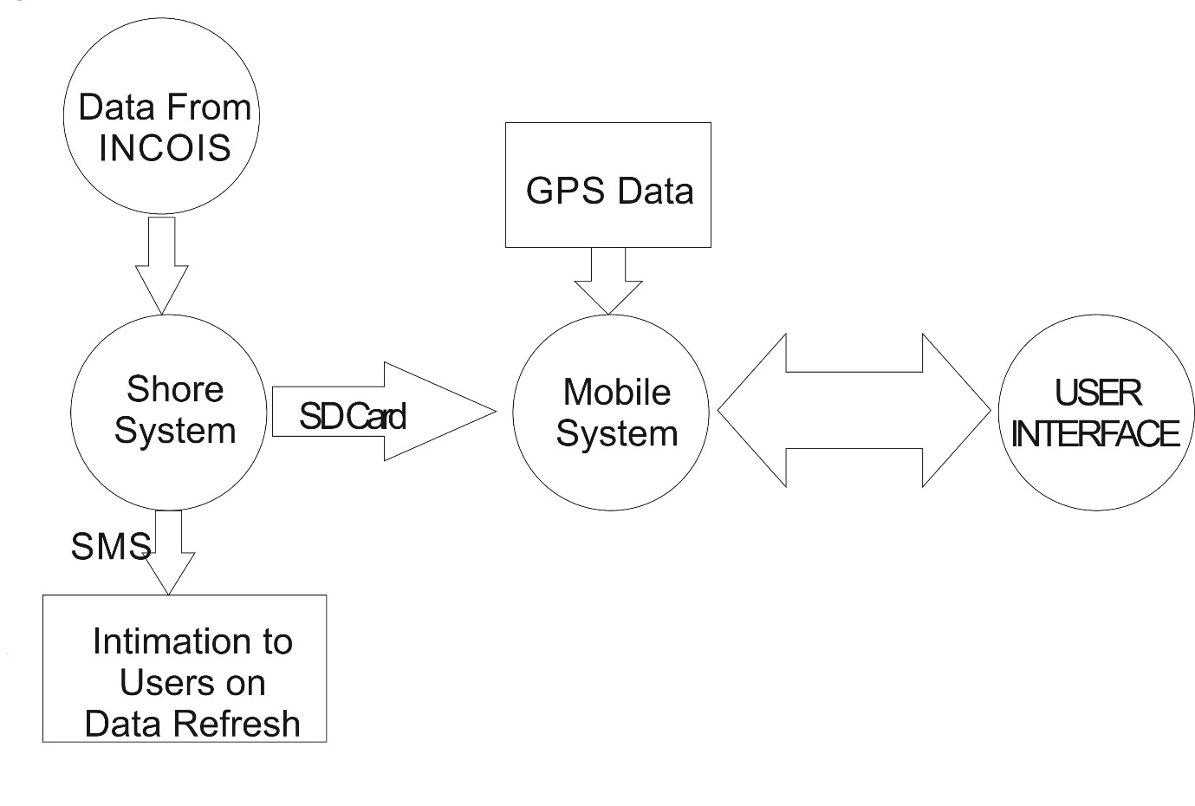

**Fig 1 Complete System Overview**

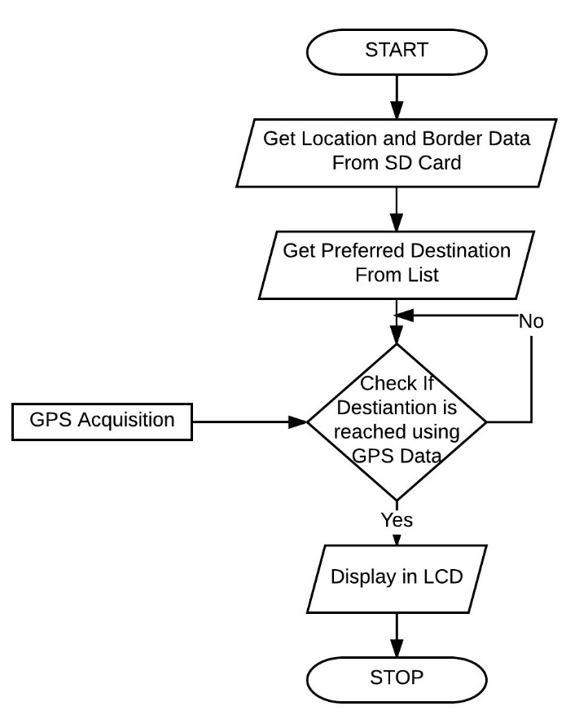

**Fig 2 Flowchart For Mobile System Operation**

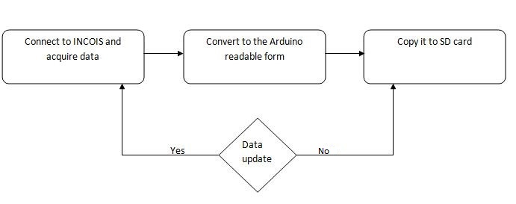

**Fig 3 Shore System Overview**

**INNOVATION & USEFULNESS**

The Mobile System also logs the present GPS Data to the attached SD Card every five minutes. At present, there is another ongoing conflict that Sri Lankan Navy arrests fishermen due to potential threat of terrorists. In such case this log can be used as a proof that they have no wrong intentions. This log can also be used by NGOs and other Government agencies to monitor and guide the efficient route to the destination and enable such organizations to provide knowledge about route planning efficiency. In Extreme Cases, if the fishermen are taken hostages by Pirates or any other anti-socialists, this GPS Log could be used as a proof for detecting and identifying the base of operations of such anti-socialistic groups.

This Project not only aims to make the Potential Fishing Zone more realistically available to fishermen but also to make the data available to lower-class fishermen too. The cost would be very minimal when compared to conventional one which makes this system a more-efficient one. The Tertiary merits of this system include that the ratio between energy used and income from fishing could increase as this system guides the fishermen directly to a more reliable area than the fishermen using their long-acquired instinctual knowledge.

The project aims at reaching the needy fishermen rather than fishermen who already exploit this valuable data. For this to happen we require a solid platform for future implementation and innovation. This award will stand out as a positive influence for us to create and innovate more in this project by investing more and encouraging young innovators to provide solutions for many other problems faced in the society.

**FINANCIAL FEASIBILITY**

|  |  |
| --- | --- |
| **COMPONENT** | **COST IN RUPEES** |
| Arduino Mega | 800 |
| SD Card Reader module | 120 |
| GPS module | 1200 |
| LCD screen | 130 |
| **TOTAL** | **2250** |

From the above table, we can observe the low cost and perfect assembling will enable this product to be a stable and error free one. Commonly, such a system is not existent to our knowledge. Since its cost is ₹2250 it is cheap and can be available for all fishermen. The Shore system is a single-time investment and it could cost between ₹8000 - ₹20000 depending on our requirement and size of the connected fishermen. The Shore System can give rise to new jobs as it needs operators who can effectively manage the systems. Servicing the faulty components on the Boat system is a need since water is involved short-circuiting of the components may occur.

**Market Potential & Competitive Advantage**

Since this is of low cost, it has the potential to reach all the classes of fishermen and it could also benefit them by reducing their energy-income ratio. Since centric systems catering to border security or data collection are present individually, the government needs to acquire the data from various sources. Our product encompasses these major aspects into a single system and offers it as one. Potential fishing zones databases have been maintained for more than a decade, process data from satellites. Using our system, we offer a secondary check-list kind of database verifying the credibility of the satellite data. The competitive edge is marked by the fact that such a system encompassing and addressing these problems hasn’t been conceived yet and a plausible yet simple solution is offered by our product. Of the ₹490 lakhs allotted by the National Fisheries Development Board under the scheme Strengthening of Database and Geographic Information System for Fisheries Sector, the manufacturing of this product can be obtained as a lease from the Central Government.

**Screenshot**

